Summary of 59 Ford Rd - sold “as is where is”

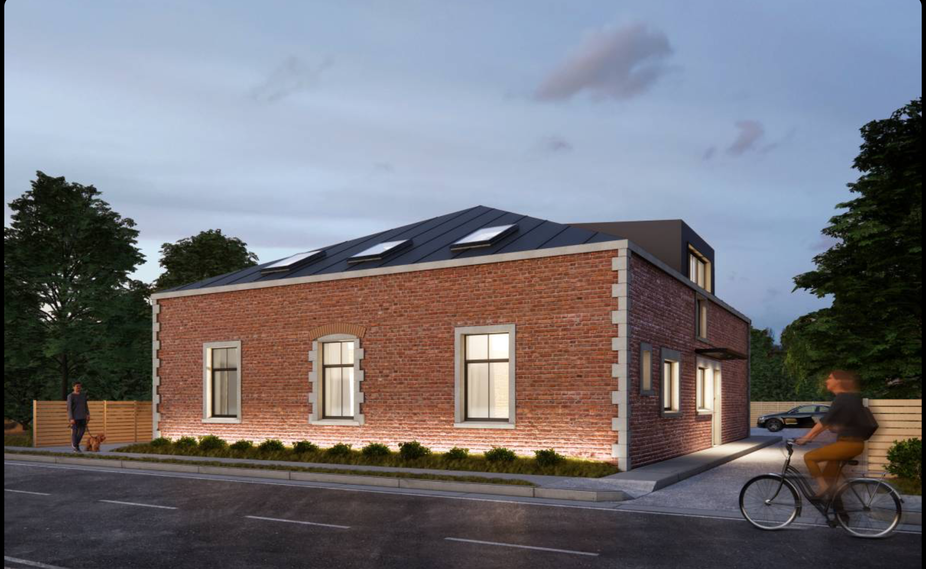

Unique opportunity to restore a large 19th century brick home in a historical and beautiful part of Christchurch.

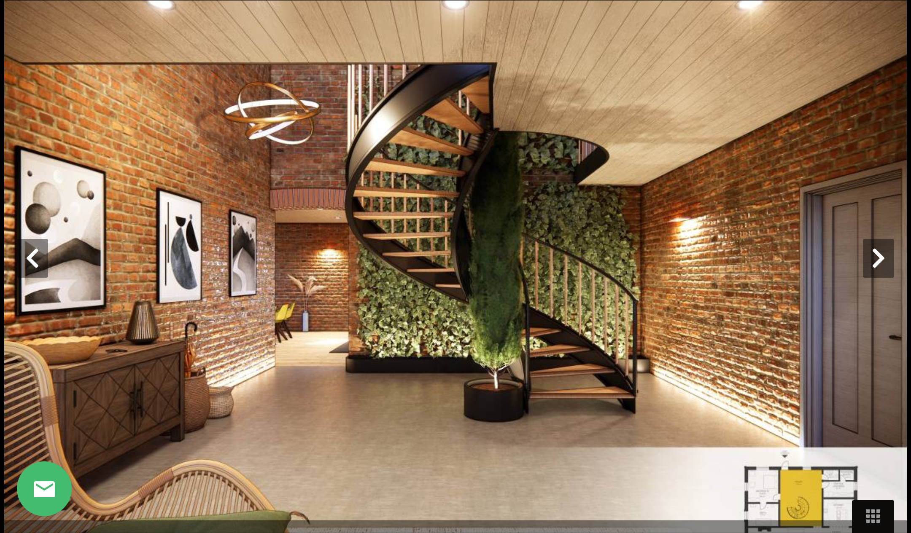

List of documents

- Engineering report
- Engineering cost
- Scaffolding quote
- Roof quote
- Windows quote
- Lim
- Property details
- Record of title

Discussion on valuation

Below is a discussion of what the value of property at ford Rd could be.

Land value - 500,000- 650,000

Cost of structural repairs, new roof/guttering, new wooden double glazed windows and doors $170,000

After this process you would have an approx 360 square meter robust, weather tight building structure that you can fit out any way you like.

The foundation and triple brick walls have lasted about 150 years through earthquakes and it would have a brand new roof, double glazed wooden windows and doors so it would be completely weather tight and secure.

The estimated cost of a new build of that size is about 1-1.6 million (3000-4500 per square m). And minus 30-40% for internal fit out means a weather tight building structure would cost 700,000-1.1 million.

Other factors that could affect valuation

- It is unique so most people would see it as more valuable than a cheap new building shell.
- It is also old so there could be some other unknowns though. However we have done the work to get the costs of the main unknowns - internal fits outs are easy once a structure is weather tight.
- The building has operated as 3 flats so there is an additional two lots of 60k that would not need to be paid for developer contribution if it was put back into 3 townhouses.
- New town houses in this area go for about $650,00 but are typically 70-80 square m. Three on this site would be 120 square m each and a lot more interesting that your typical new town house - see some of the concept plans below.
- Press article compares it to Britten stables that sold for 7.8 million (obviously smaller and not fendalton….but still unique opportunity)
https://www.thepress.co.nz/nz-news/360544879/historic-dilapidated-opawa-stables-seek-new-visionary-owner
- No heritage listing so no limitations on your designs.
- Some concept designs have been done that are included with this sale.
- https://www.arcbazar.com/interior-designs/project/daniel-dimitrov-1880-brick-stables-renovation-australia
- https://www.arcbazar.com/interior-designs/project/nad-atelier-1880-brick-stables-renovation-australia
- https://www.arcbazar.com/project/1184023766
- https://www.arcbazar.com/project/3059952506

Summary

- Land $500,000-650,000
- Building shell $700,000-1,100,000
- Cost of repairs etc $170,000
- Other bits could put it up or down further depending on your view of information above.

Total value has a probable range of $1,030,000-$1,580,000 plus. We are considering all offers so feel free to put one so you don’t miss out.

