Building Inspection 5 Joshua Place, West Melton
11 September 2025
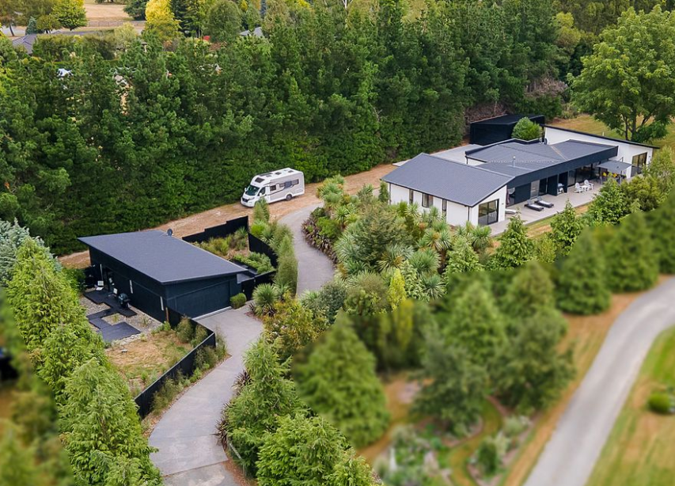
Date of inspection: 11 September 2025
Inspection by: Neville Bates
Qualifications: Trade Certificate
LBP: 104247
Master Builder: Company has been a Master builder since 1957
Experience: 47 years as a builder, insurance repair specialist since 1990
Contact details: Ph 027 275 5089 neville@batesbuilders.co.nz
Owner: Philip Hextall & Gail Sharman
Contact details: 021 747 005 philiphextall@myyahoo.com

Contents:
A: Overview
B: Inspection
C: Conclusion
D: Definitions
E: Limitations of method
F: Terms and conditions
- Appearance defect: Fault or deviation from the intended aesthetic appearance of the building element
- Building element: A part of the building that, by itself or in combination with other parts fulfils a function.
- Defect: Fault or deviation from the intended condition of a material or component.
- Limitation: Any factor that prevents full or proper inspection of the component or building.
- Major fault: A defect of sufficient significance requiring immediate rectification to avoid unsafe conditions, and or loss of utility and or further deterioration of the property.
- Minor Defect: An item taking into consideration the age, type and use of the building does not require immediate attention or substantial repairs. Note that minor defects are common and reflect normal wear and tear which regular maintenance will address.
- Significant fault: An item that requires urgent and substantial rectification.
- Structural defect: Condition of a structural component that significantly degrades its intended performance.
- Urgent serious Hazard: An issue which presents an immediate potential threat of injury to persons.
- Scale 1-5 This is a widely recognized international standard where:
  - 5 is Excellent
  - 4 is Very Good
  - 3 is Average
  - 2 is Fair
  - 1 is Poor

A: Overview
The property is located at 5 Joshua Place, Little Edendale, West Melton on a residential section measuring 5,174m2. (Lot 10 DP 378670 BLX ROLLESTON SD). The house was built 2014-15.
Selwyn District Council Land Information Memorandum L250412 Valuation 2419000172.
The main house consists of four bedrooms, open plan kitchen, dining room, living room, lounge, utility room, one bathroom, one large ensuite, including three toilets and one hallway. There is a large walk-in wardrobe servicing the master bedroom. The area is of the main house is approximately 250 square metres.
The main building is simple rectangular structure with two smaller rectangles each end of the main rectangle.
It sits on concrete slab and is timber framed with a mix of Hebel and Shadowboard. The roof is mono-pitch. Joinery is aluminium framed.
The exterior is painted white and black.
A fully detached double garage (Versatile) measuring 42m2 is located nearby. This garage was built in 2024. The garage is clad with black Stratco long run iron and has a mono pitch roof. The interior is lining with 9mm plywood.
At the front of a property is another building (sleepout) which consists of a double garage (36m2) and a unit consisting of an open plan bedroom, living room, kitchenette with a bathroom leading off from the main area. This building is clad with Shadowboard and has a mono pitch long run iron roof. This building has a square area of 72m2.
B: Inspection
The inspection was carried out on Thursday 11 September 2025 with one of the homeowners present. An exterior inspection was carried out initially followed by an inspection of the interior.
The inspection examined general construction, cladding systems, electrical, plumbing, drainage, heating and ventilation, fittings including bathrooms and kitchen, furnishings, outdoor components such as decking and paving.
- Site – the site is on mostly flat ground rising approximately 1.2metres from the gate to the main house. The land consists of alluvial topsoils sitting on about 30 metres of river shingle. This not only provides excellent drainage but acts as an insulator for seismic events. The Selwyn Council flood maps shows this area is not a flood zone.
- Foundation -The foundations consist of poured concrete slabs. We noted no issues apart from normal shrinkage cracks in any of the slabs. There is no evidence of earthquake damage. (Rating 4/5).
- External walls – the Hebel is in good order with some minor blemishes present. The Shadowboard likewise was in good condition with minor blemishes between sheets due to movement from expansion / contraction due to heat / cold. (4/5). The paint is good condition. I understand from the homeowner that house was repainted approximately five years ago.
- Windows and external doors / ranchsliders / stackers. There are no obvious issues with any of these components. The handles on the ranchsliders are all present and functional. The window catches are all function with only one missing a minor flap. The stacker system operates as intended. (4.5/5)
- Garage doors – both sectional vehicle doors are operational with no issues. (5/5).
- Roof – the roof systems are all sound with no obvious issues. Protrusions such as vents are well sealed and there is no evidence of leaks. Gutters, traps and downpipes are clear mostly of debris. There are some pine needles from a storm the previous night but no built -up residual). (4.5/5)
- Attic space – no issues were detected. Insulation was present in all the areas we could access. The roof space above the main living area is inaccessible but there is no indication of any issues. (5/5)
- Internal walls – Walls are plasterboard either painted white or decorated with colourful murals. The lounge is wallpapered. The murals are in excellent condition, and the walls are in good condition with a little wear and tear evident particularly around the en-suite area. The lounge wallpaper appears to be new. The plasterboard is generally in good condition. There is one section of plasterboard in the main bathroom behind the cistern which has a small construction hole in it which the original builders did not remedy. This is only visible when the cistern lid is removed. Otherwise, the plasterboard is good. There is no evidence of any moisture issues. The skirting boards are in reasonable condition with some general wear and tear evident.
- Internal doors - they are a mix of side hung hollow core doors and ceiling to floor sliders are in good condition with the only obvious issue being the small slider to the electronic hardware cupboard which has a rub mark 2/3 of the way up. The ensuite door is also marked. (4/5)
- Electrical systems - appear to operate without issues. There is some wear and tear on the main light switch casing but otherwise all the fittings are sound. Light fittings appear to be in excellent condition. (Rating 4.5)
- Joinery
  - Kitchen – High quality lacquered joinery, Blum internal – good condition (4/5)
  - Bathroom – good condition (4/5)
  - Utility room – good condition (4/5)
  - Power room – good condition (4/5)
  - En suite – good condition (4/5)
  - Wardrobes – good condition (4/5)
  - Sleepout – generally good condition – bench top small mark (3.5/5)
  - Kitchen bench top – black granite in excellent condition (4.5/5)
- Showers – good condition – Readings are acceptable and there is no evidence of any issues. Mixers and drainage work well on all shower and basins. (4/5)
- Mirrors – there are three fitted mirrors in the main house and one in the sleepout. All are in excellent condition. (5/5).
- Ovens- Twin Gaggenau wall overs. In excellent condition. (5/5)
- Hob – Bosch six burner hob – no issues (4.5/5)
- Bosch extractor – no issues (4.5/5)
- Plumbing- Most fittings are Hansgrohe and in excellent condition. Toilets are Caroma and in excellent condition. (5/5)
- Hot water cylinders- both cylinders appear to be sound. No issues identified. (5/5)
- TVs/ Audio- the house is equipped with a high-quality integrated sound system divided into six zones which can operate independently. There also five wall mounted TVs and another in the sleepout. These all operate as intended and no issues were identified. (5/5)
- Alarm – the house has an alarm system. We did not test this.
- Heated towel rails – there is one in the sleepout and the two in the mina house. All are in excellent condition and functional. (5/5)
- Smoke alarms – they are present in both the house and sleepout. We did not test.
- Gas fire – there is a wall mounted gas fire which services the lounge and living area. This was tested and found to operate as intended. (5/5)
- Mechanical ventilation – extractors in ensuite, main bathroom and sleepout bathroom. Bosch extraction unit over the hob. All operational and in very good condition. (4.5/5)
- Heat pumps – the master bedroom has a 3.5 kw Mitsubishi heat pump which also acts as air conditioning. This appears to be in excellent condition. The sleep out has a Mitsubishi 5.8kw heat pump which appears to be sound. (4.5/5)
- The main house also has underfloor heating throughout which uses hot water as the basis of the heating. A SIRAC 15.9kw heat pump. This was in operation at the time of our inspection and there were no obvious issues. (4.5/5)
- Furnishings
  - BR2 – black curtains – some bobbles missing (3/5)
  - Bathroom – venetian blinds – good condition (4.5/5)
  - BR 3 – Blinds – excellent condition (5/5)
  - Lounge – Heavy high-quality curtaining and bespoke blind – excellent (5/5)
  - LR-Kitchen- DR – Window Treatment blinds – good condition (4/5)
  - MBR – heavy black curtains – excellent (4.5/5)
  - Ensuite net curtains – good condition, (4/5)
  - Black nylon Rhino carpet – excellent (4.5/5)
- Paving / driveways – the property has an extensive concrete driveway leading from the gate to the fully detached garage. There is some cracking near the gate but nothing of concern. (4/5)
- Electric gate – 12v remote control gate with keypad – no issues identified (4.5/5)
- Decking – Extensive Outdure synthetic decking. The decking has no fading, buckling etc. There is some splitting, but this is minor aesthetic. (4/5)
- Decking – sleep out. There are two areas of decking both constructed of pine. The older area is in good condition with minor wear and tear and the newer area which incorporates seating is in new condition. (4.5/5)

C. Conclusion:

The property is a modern sound well- maintained property with no obvious issues. There is some wear and tear which is expected with a property 10 years of age but nothing requiring urgent attention.

I would rate the property 4.5/5.

D: Definitions:
Access hole (cover) | An opening in flooring or ceiling or other parts of a structure (such as service hatch, removable panel) to allow for entry to carry out an inspection, maintenance or repair.
Accessible area | An area of the site where sufficient, safe and reasonable access is available to allow inspection within the scope of the inspection.
Building element | A portion of a building that, by itself or in combination with other such parts, fulfils a characteristic function. NOTE: For example supporting, enclosing, furnishing or servicing building space.
Client | The person or other entity for whom the inspection is being carried out.
Common Property (NZ) | An area that is owned collectively by all the unit owners and defined as such in the relevant documents. Note - Individual unit owners have no particular right to any part of the common property and their interest is not recorded on title however they have a responsibility for paying a proportionate share of related outgoings. Areas can include gardens, driveways, roof spaces, the exterior fabric of the building, service areas, units occupied by building managers etc.
Defect | Fault or deviation from the intended condition of a material, assembly, or component.
Detailed assessment | An assessment by an accredited sampler to determine the extent and magnitude of methamphetamine contamination in a property.
EIFS (Abbreviation) | External Insulation Finishing System
Inspection | Close and careful scrutiny of a building carried out without dismantling,
in order to arrive at a reliable conclusion as to the condition of the building.
Limitation | Any factor that prevents full or proper inspection of the building.
Major defect | A defect of sufficient magnitude where rectification has to be carried out in order to avoid unsafe conditions, loss of utility or further deterioration of the property.
Minor Fault or Defect | A matter which, in view of the age, type or condition of the residential building, does not require substantial repairs or urgent attention and rectification and which could be attended to during normal maintenance. Note - Minor defects are common to most properties and may include minor blemishes, corrosion, cracking, weathering, general deterioration, unevenness, and physical damage to materials and finishes. It is common for most of these defects to be rectified over the first few years of ownership as redecoration and renovation are undertaken.
OSH (Abbreviation) | Occupational Safety and Health
RCD (Abbreviation) | Residual Current Device
Reasonable Access (NZ) | Areas where safe unobstructed access is provided and the minimum clearances specified in table 1 of NZS 4306:2005 are available or where these clearances are not available, areas within the inspector's unobstructed line of sight. Note - It shall be clearly stated if no access was available, or access to limited areas only was available at the time the inspection was carried out.
Roof space/Roof void | Space between the roof covering and the ceiling immediately below the roof covering.
Significant Fault or Defect | A matter which requires substantial repairs or urgent attention and  rectification.
Significant item | An item that is to be reported in accordance with the scope of the inspection.
Site | Allotment of land on which a building stands or is to be erected.
Structural defect | Fault or deviation from the intended structural performance of a building element.
Structural element | Physically distinguishable part of a structure. NOTE: For example, wall, columns, beam, connection.
Subfloor space | Space between the underside of a suspended floor and the ground.
Survey | A separate, detailed inspection and report that may require invasive and/or specialised testing equipment and may require the specialist knowledge of a relevantly qualified expert.
Urgent and Serious Safety  Hazards | Building elements or situations that present a current or immediate potential threat of injury or disease to persons.

E: Limitations of method
The inspection is on-invasive and depends mostly on visual observation. This has included looking for evidence of any issues including the general appearance, odour, and the general feel of the property, the sound of materials when tapped and the presence or absence of mould, mildew etc.
I note that non-invasive (pin less) moisture meters have limitations including surface-only readings and inaccuracy with conductive materials, such as metals, and materials with high mineral content or varying densities, like concrete and ceramic tiles.

They also struggle with deeply embedded moisture, cannot measure moisture content in some loose materials, are affected by ambient humidity and temperature, and require the meter's plate to be flat against the surface for a good reading. Concrete and ceramic tiles are porous and naturally can hold moisture. Underfloor heating as is present in this house, and which utilises water will also give rogue readings.
Other indicators of an issue are usually present such as odour, mildew, rot, fungi, drumming of tiles. One indicator alone does not mean a definite problem.

F: Terms and Conditions:
This report has been prepared in accordance with the pre-inspection agreement between the parties which set out the purpose and scope and limitations of the inspection.
The report reflects the opinion of the builder’s inspector based on his observations made on the day.
The report should be read and considered in its entirety and in the context of the agreed scope and agreement with the owner. It does not deal with every aspect of the property
If there is a discrepancy between the summary and the body of the report the body of the report will prevail.
If you have any queries with the report or require further information, please do not hesitate the person who carried out the report.

G: Photos

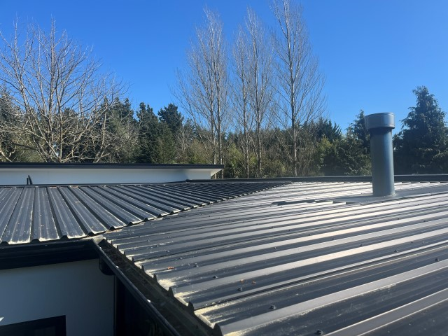
General view of roof – clean except for temporary pine tree pollen
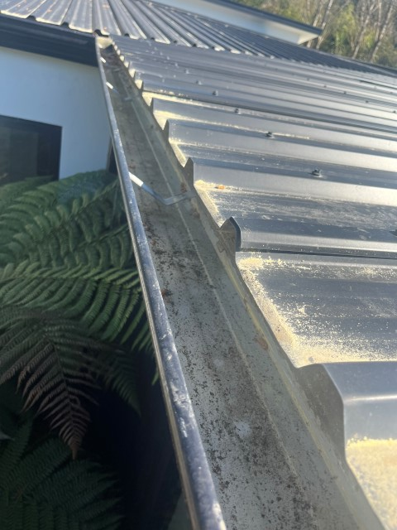
Detail showing gutter

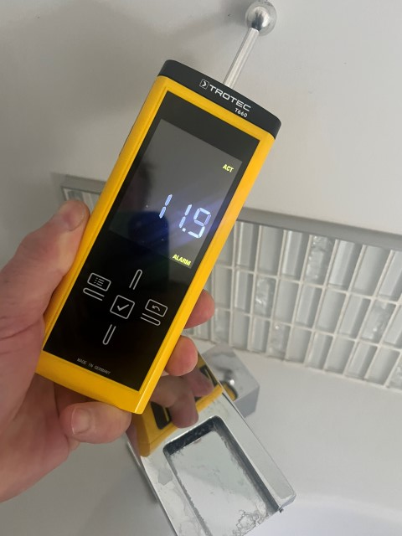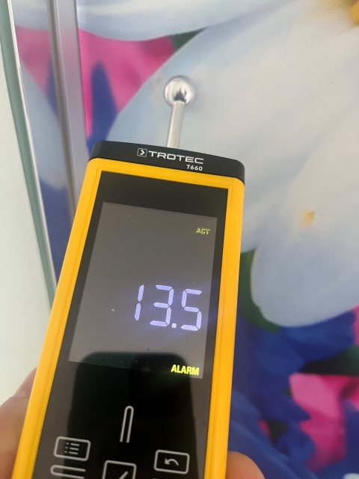
Moisture readings – all sound

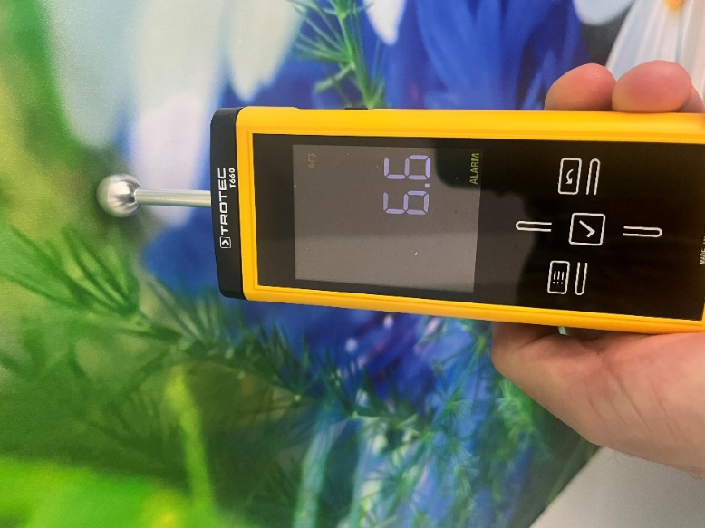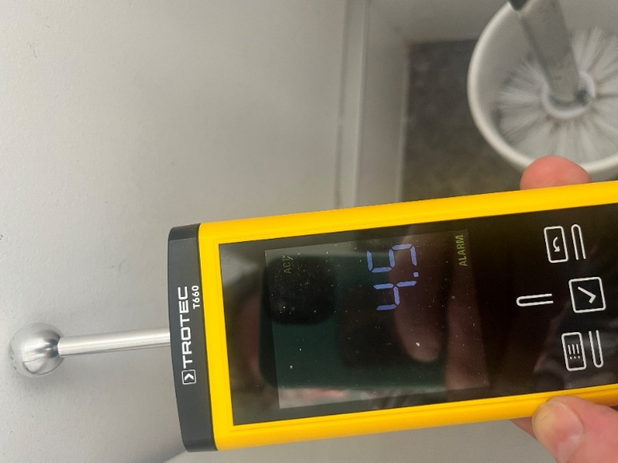

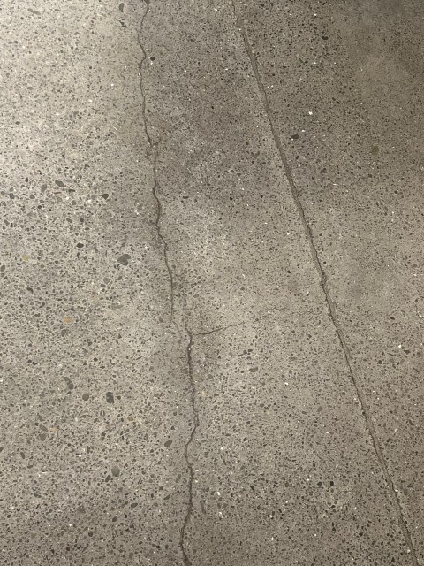
Shrinkage cracks in concrete floor
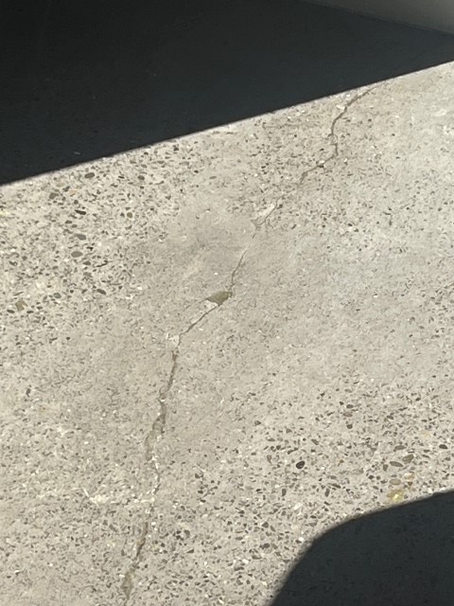

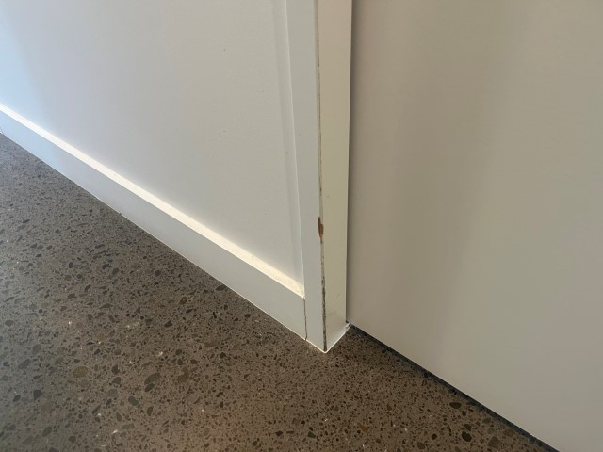
Typical minor wear and tear

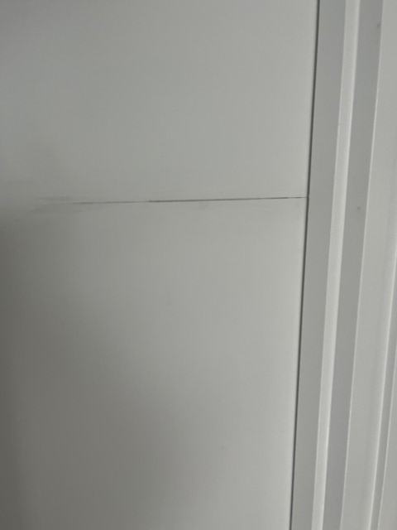
Gouge on media cupboard sliding door

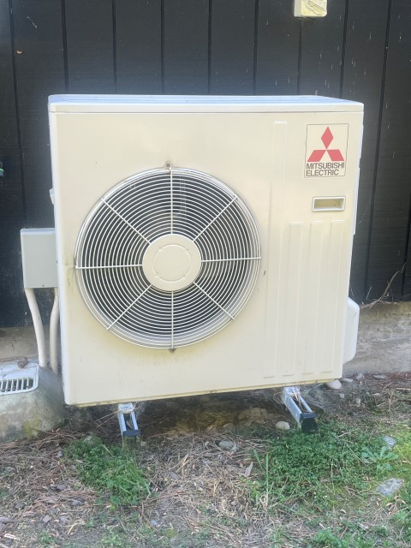
Sleepout heat pump
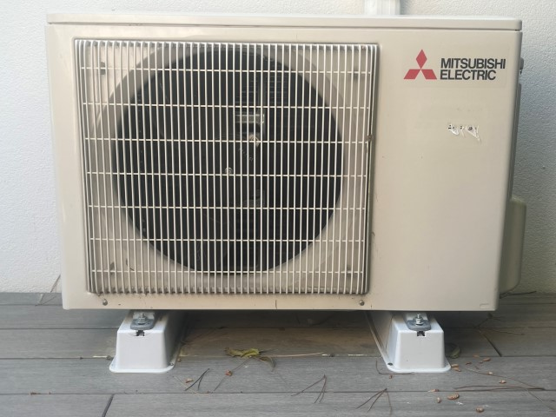
Master bedroom heat pump
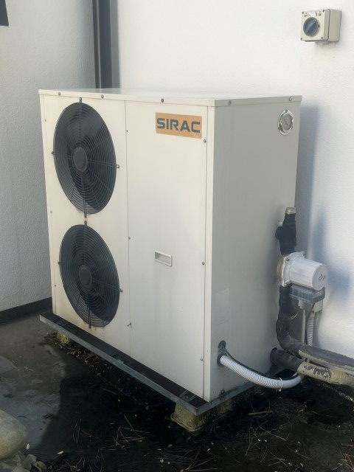
Underfloor heat pump

